**GO-STANDARD NURSERY & PRI-SCHOOL**

**END OF YEAR EXAMINATION 2023**

**PRIMARY ONE**

**MATHEMATICS**

**My name is ___________________________________________**

**I am in ________________________________________________**

**My school is __________________________________________**

**SECTION : A. (40 MARKS).**

1. **Count and write the number word**.

a) = b) =

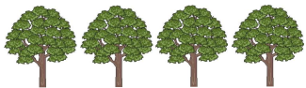c) =

2. **Fill in the missing number**.

a) 1st 2nd ____, 4th , 5th . b) 0, 2, 4, 6, ____, 10, 12, 14.

3. **Add :**

a) 10 + 2 = b) 4 + 3 + 5 =

c) 1 3

+ 2 4

4. **Draw these sets**

a) A set of two balls b) A set of 3 chairs.

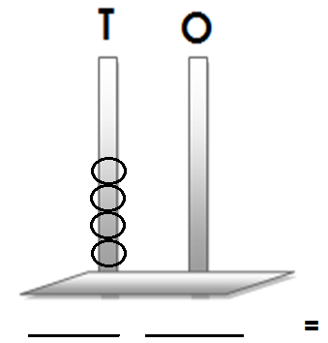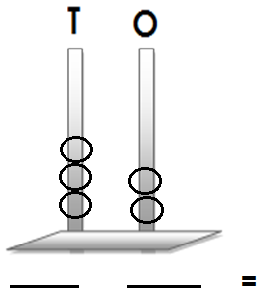5. **Count and write the number.**

a) b)

6. **Draw tens and ones.**

a) 14 = b) 20 =

7. **Subtract/Takeaway.**

a) 9 – 5 = b) 8 c) 4 4

- 6 - 1 2

8. **Circle the greater number.**

a) 6 and 9 b) 12 and 10 c) 1 2 and 20

**SECTION : B (60 MARKS)**

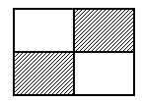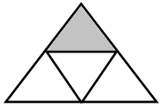9a) **Name the shaded fractions**.

i) ii)

b) **Add these fractions.**

i) 3 + 2 = ii) 4 + 1 =

8 8 9 9

10. **Tables/Times.**

a) 2 x 2 = b) 5 x 3 =

c) 7

x 2

11. **Draw these shapes.**

a) Rectangle b) Oval.

12. **Use +,−, x to complete correctly**.

a) 2 ___________ 2 = 4

b) 3 ___________ 1 = 4

c) 5 ___________ 2 = 3

13. **Match correctly.**

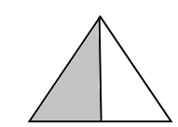

whole



a half

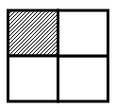

a third

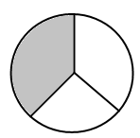

a quarter

14. **Find the missing numbers.**

a) + 2 = 4 b) - 2 = 3

c) + 4 = 8 d) - 5 = 10

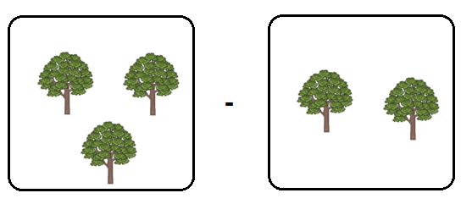15. **Subtract the sets.**

=

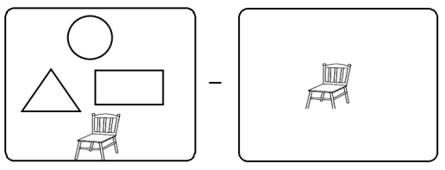



b) =

16. **Study the graph and answer the questions correctly**.

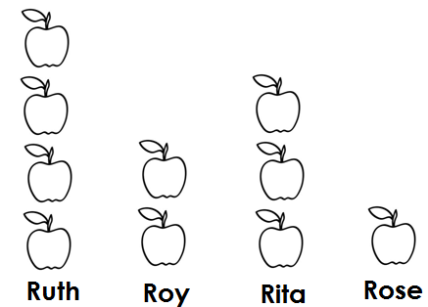

a) Rita has _____________________ apples.

b) Who has four apples?

________________________________________________________________________

c) _______________________________ has few apples.

d) How many apples do they have altogether?

_______________________________________________________________________

17. **Read, understand and show the working.**

a) Two groups of two give_________________________________________________

b) How many legs do 3 dogs have?

c) Lorna has 4 eggs. Maria has 6 eggs. How many eggs do they have altogether?

d) Subtract six from twelve.

